Big y cheat sheet
Brought to you by pounds transformation

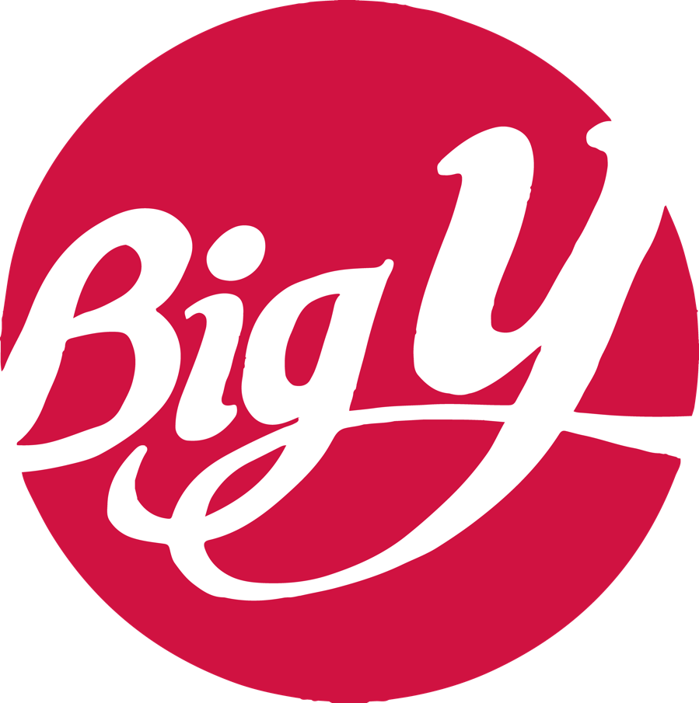

*Easy grab n’ go & precooked options!
Meats:
- Springer Mountain Chicken Burgers (2 g net carb, 20 g protein)
- Wild Spark Bruschetta Chicken Patty (1 g net carb, 19 g protein)
- Plainville Organic Turkey Burgers (0 g net carb, 22 g protein)
- Wild Caught Terriyaki Salmon Burgers (5 g net carbs, 14 g protein)
- Big Y Frozen Beef Burger (0 g net carb, 20 g protein)
- Pier 33 Wild Caught Tuna Burgers (6 g net carbs, 23 g protein)
- Naked Cooked Shrimp (0 g net carb, 15 g protein)
- Al Fresco Chicken Sausage (2 g net carbs, 13 g protein)
- Applegate Uncured Beef Hotdog (0 g net carb, 7 g protein)
- North Country Smokehouse Polish Kielbasa (0 g net carb, 8 g protein)
- Applegate Breakfast Sausage (1 g net carb, 9 g protein)
- Applegate Sunday Bacon (0 g net carbs, 7 g protein)
- Hormel Turkey Pepperoni (0 g net carb, 9 g protein)
- Realgood Chicken Tenders/Nuggets (3 g net carbs, 23 g protein)
- Tyson’s Blackened Unbreaded Chicken Strips (1 g net carb, 20 g protein)
- Perdue Short Cuts Grilled Chicken Strips (1 g net carb, 20 g protein)

Vegetarian:
- All American Boca Burger (4 g net carb, 14 g protein)
- MorningStar Garden Veggie Burgers or Griller Crumbles (5 g net carb, 11 g protein)
- MorningStar Veggie Sausage (3 g net carbs, 9 g protein)
- Quorn Meatless Pieces (5 g net carbs, 17 g protein)
- Lightlife Smart Dogs (3 g net carbs, 12 g protein)
- Lightlife Deli Slices (2 g net carbs, 13 g protein)

Dairy:
- Fairlife Milk (6 g net carbs, 13 g protein)
- Silk Cashew Milk (for those who think almond milk is too watery!) (2 g net carbs, 1 g protein)
- Silk Unsweetened Almond Milk (1 g net carb, 1 g protein)
- Planet Oat Unsweetened Oat Milk (I try to discourage oat milk, but this a better one) (7 g net carbs, 1 g p)
- Nut Pods Unsweetened Creamer (0 g net carb, 0 g protein)
- Smart Balance Light Butter (Dairy Free) (0 g net carb, 0 g protein)
- Chobani Zero Sugar Yogurt (This is lactose-free!) (5 g net carbs, 11 g protein)
- Cabot Light Cheese (This is lactose-free!) (1 g net carb, 9 g protein)

Cereals/Breads/Wraps:
- Catalina Crunch Cereal (5 g net carb, 11 g protein)
- Premier Protein Cereal (12 g net carbs, 20 g protein)
- Nature’s Own Keto Bread (My favorite brand of bread!) (1 g net carb, 6 g protein)
- Old Tyme Schmidt 647 Bread (all varieties) (6 g net carb, 2 g protein)
- Sara Lee Delightful 45 Bread (6 g net carbs, 2 g protein)
- Arnold Keto Sandwich Thins (4 g net carbs, 12 g protein)
- Arnold Keto Hamburger/Hotdog Buns (6 g net carbs, 9 g protein)
- Mission Carb Balance Tortillas (3 g net carb, 5 g protein)
- Mission Zero Net Carbs Street Tacos (0 g net carb, 2 g protein)
- Joseph’s Pita / Lavash Bread (in deli section) (7 g net carb, 6 g protein)

Pasta/Rice:
- Al Dente Carba-Nada Fettucine (17 g net carbs, 15 g protein)
- House Foods Shiratki Noodles (in produce aisle, good for ramen substitute) (2 g net carbs, 2 g protein)
- Banza Protein Pasta (24 g net carbs, 13 g protein)
- It’s Skinny Rice (0 g net carbs, 0 g protein)
- Green Giant Cauliflower Rice (2 g net carbs, 2 g protein)

Protein Bars/Shake: (I recommend Pounds protein bars because they are overall cheaper in price per bar but these are some great Big Y options!)
- Fit Crunch Bars (13 g net carbs, 16 g protein)
- Quest Bars (6 g net carb, 21 g protein)
- NuGo Slim Bar (vegan, make sure it says “slim”, the other ones are high in sugar!) (10 g net carbs, 16 g p)
- Premier Protein Shakes (2 g net carb, 30 g protein)
- Quest Protein Shake (3 g net carb, 30 g protein)
- Quest Protein Powder (2 g net carbs, 24 g protein)
- Kos Protein Powder (vegan!) (6 g net carbs, 20 g protein)
- Vital Proteins Collagen Peptides (unflavored!) (0 g net carb, 20 g protein)

Snacks:
- Quest Chips (4 g net carbs, 19 g protein)
- UTZ Pork Rinds (0 g net carbs, 8 g protein)
- Wasa Light Rye Crackers (7 g net carbs, 2 g protein)
- Blue Diamond 100 Calorie Nut Pouches (1 g net carb, 4 g protein)
- Formaggio Artisan Prosciutto/Cheese Wraps (0 g net carbs, 12 g protein)
- Tillamook Zero Sugar Beef Jerky (0 g net carbs, 14 g protein)
- Chef’s Cut Zero Sugar Biltong Jerky (1 g net carb, 26 g protein)
- Frigo Light String Cheese (1 g net carb, 6 g protein)

Sauces/Condiments/Dips:
- Teddy’s All-Natural Peanut Butter (4 g net carb, 8 g protein)
- Skinny Girl Fruit Preserves (1 g net carb, 0 g protein)
- G Hughe’s SF Sauces/Condiments (2 g net carb, 0 g protein)
- Bolthouse Farms Salad Dressings (3 g net carbs, 0 g protein)
- Skinny Girl Salad Dressings (2 g net carbs, 0 g protein)
- Yo Mama’s Tomato Sauce (4 g net carbs, 1 g protein)
- Classico Creamy Alfredo Sauce (1 g net carb, 1 g protein)
- Cedar’s Spinach Artichoke Tzatziki (3 g net carbs, 2 g protein)
- La Ferra Tina Everything Bagel Dip (3 g net carbs, 2 g protein)

